### Product Analysis

#### UI tests

The first test should be checking the user interface. The appearance and layout of the fields should be in accordance with the requirements.

* After starting the test, a pop-up appears with information about cookies fields (for the purposes of the rest of the tests, the pop-up is closed with the "Accept all" button)
  + appearance and layout of the pop-up containing information about cookies is checked.
* Google browser logo appears in the center of the page.
* Directly below the logo search box for entering search terms/phrases is located.
* There are three icons on the search box.
* Below, two buttons arranged in a row: "Szukaj w Google" and "Szczęśliwy traf".
* In the upper right corner are the buttons "Gmail, "Grafika", Google apps and Google Accounts - "Zaloguj się".
* In the upper left corner are two buttons called "O nas" and "Google store".
* Page also contains information about the browser language.

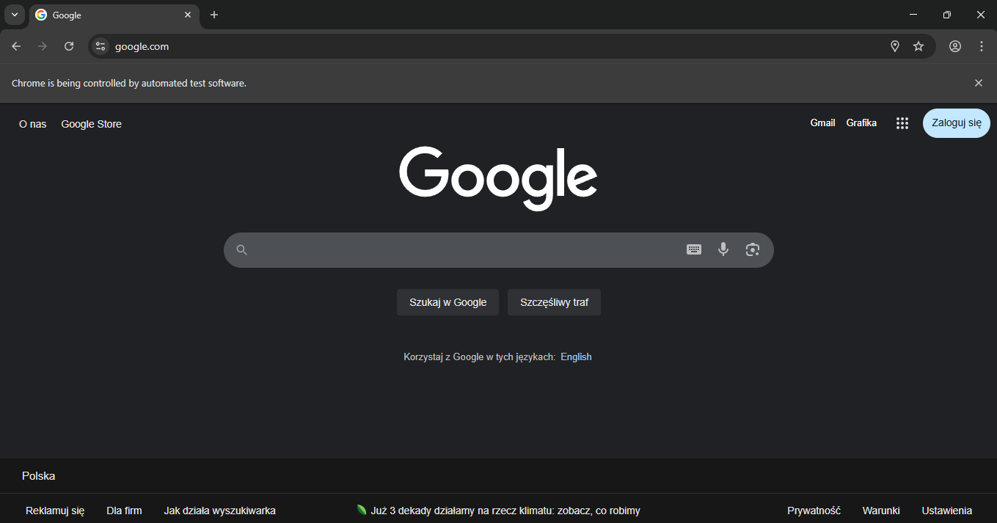

#### Smoke tests

Then, there is a need to perform smoke tests, which include checking the main functionalities of the product, the most important of which is the happy path.

##### Happy path

Main task of Google Home Page is to search on the internet for terms and phrases provided by the user. Value that the user is interested in is entered into the indicated search box. During this process, suggestions are listed under the tested field. User can finish entering the entry themselves and search for the entry, or select one of the suggestions provided. Selecting one of the options will transfer the user to a page with the results listed. Transfer will occur after accepting the option by pressing the enter button or selecting the Google Search option from the list of suggestions and immediately after selecting another option from the list of suggestions.

#### Buttons functionality

It is necessary to check the functionality of all buttons on the website.

* Functionality of all cookies field pop-up buttons works as intended; e.g. the button for accepting and rejecting files closes the pop-up, button for changing the language displays available options and saves the selection
* Click on the search box lists past queries if they exist, if not popular searches are listed.
* Clicking on Gmail takes to the Google email login page.
* Clicking on the Images button takes to the Google images search page.
* Clicking the Google apps icon opens a tab where application icons appear, all the required apps are in the tab and behave as required.
* After pressing the Google Accounts button, the account login tab opens. Correct elements are there.
* The "O nas", "Google store", "Szczęśliwy traf", and "Szukaj w Google" buttons take the user to the appropriate pages.
* Information about languages ​​allows to change the browser language to any of the available options.
* Text input tool allows to enter a search term using the on-screen keyboard; the keyboard must consist of the appropriate characters and enter and search for the term in the search box.
* Voice search functionality opens a page with the functionality for recording search term.
* Search by images allows to search any image with Google Lens. Opens a pop-up that has built-in file insertion functions.

#### Testing Tools

Based on available information about the product and its analysis for testing purposes, tools are selected that will optimize these tests.

##### Tools that were selected to prepare tests

* Selenium
* C#
* ChromeDriver for Chrome browser